International Journal of Geographical Information Science
Vol. 00, No. 00, Month 0000, 0–0

RESEARCH ARTICLE

Route-based Geocoding of Traffic Congestion-Related Social Media Texts on a Complex Network
Saif Ali^{ab∗}, Mohammad Faraz Idris Siddiquiª, Mohammad Faizª, Adeeba Haroonª

a Department of Computer Engineering, Jamia Millia Islamia, New Delhi, India;
b Department of Social Sciences and Humanities, Indraprastha Institute of Information Technology, Delhi, India

Abstract
Urban traffic congestion is a complex, networked flow, yet traffic-related social media texts are commonly geocoded as isolated point locations. Point-based representation is inadequate because congestion is typically described as movement along roads, between origins and destinations, and through directionally constrained corridors. We propose a route-based geocoding framework that maps traffic-related tweets to route primitives rather than points. The framework combines a traffic-specific spatial ontology with a syntactic geocoder that detects toponyms, directional and locative prepositions, and named linear features to construct spatial route queries. The ontology adapts prior geometric-configuration and point/link abstractions, while introducing five route-bearing configurations for traffic discourse, including landmark-constrained, road-constrained, and point-on-line relations. These configurations capture substantial spatial information that earlier point/link abstractions would collapse or miss. We apply the method to five years of New Delhi traffic alerts and map inferred routes to a directed road network. Route aggregation produces a weighted congestion network supporting centrality analysis, source-sink interpretation, and bottleneck detection. Validation using traffic and non-traffic tweets from New Jersey shows that traffic texts contain recoverable route-bearing spatial information, offering a scalable basis for congestion monitoring and transport policy.

Keywords: Route-based Geocoding; Social Media Texts; Traffic Congestion; Urban Complex Networks
∗Corresponding author: g.saifa@jmi.ac.in
This research received no specific grant from any funding agency in the public, commercial, or not-for-profit sectors.

1 Introduction

Urban traffic congestion imposes large economic, environmental, and social costs (Dash 2017). Sensor and CCTV-based monitoring can be costly to deploy at scale, spatially sparse, and constrained by privacy and governance. Geosocial media have become a major source of volunteered geographic information (VGI) about urban mobility (Goodchild 2007; Elwood et al. 2012). Traffic-related posts like stranded-driver distress messages and official alerts, can be analyzed as geosocial traces to reconstruct partial impressions of historical and near-real-time congestion and disruptions (Crooks et al. 2015; Steiger et al. 2015; Shelton et al. 2015). As a result, VGI-based traffic intelligence has drawn sustained attention for planning, monitoring, and congestion management (Basu et al. 2017; Agrawal and Kuriakose 2022; Fontes et al. 2023).
Posts on X (formerly Twitter) provide a rich stream of near–real-time traffic-related texts (Stock 2018). Extracting spatial meaning from these texts requires geocoding: inferring the locatum, or the location being referred to, from tweet content. Most geocoding in this domain is point-based, mapping toponyms (place names) to spatial coordinates. While effective for many tasks, point geocoding reduces complex, context-dependent place references to a single location. For traffic discourse, this is inadequate because congestion is inherently linear and directional, unfolding along roads and corridors. Nevertheless, most prior work in traffic-text geocoding relies on point-based approaches (Das and Purves 2020), limiting downstream analyses such as propagation and flow modeling.
We advance a different premise: for traffic-related texts, the natural geocoding primitive is a route, not a point. We define a route as a directed path specified by an origin, a destination, and (when available) intermediate constraints such as landmarks or named roads. This representation aligns more closely with how traffic events are described and experienced—along connected road segments with direction of movement.
We present a route-based geocoding method for extracting location, movement, and flow direction from traffic-related social media texts. We apply the system to a five-year corpus and aggregate inferred routes to construct a complex-network representation of reported congestion in New Delhi (India), enabling network-level analysis of congestion patterns.
Our contributions are fourfold. First, we propose a route-based geocoding framework that infers directed routes from traffic-related social media texts rather than isolated point locations. Second, we develop a traffic-specific spatial ontology of twelve geometric configurations. The ontology adapts general geometric-configuration concepts (Stock, 2018) and extends the point/link abstractions used in earlier traffic-text geocoding work. Seven configurations operationalize point, line, origin, destination, and origin-destination structures present in prior work (Wanichayapong et al., 2011), while five are introduced here to capture richer route-bearing expressions involving multiple destinations, intermediate landmarks, named-road constraints, point-on-line relations, and point-with-destination movement. These extensions capture complex spatial relationships that account for a substantial share of recoverable spatial information in traffic texts and would be missed or collapsed if the ontology were restricted to earlier point/link abstractions. Third, we develop an NLP-based syntactic analyzer that operationalizes this ontology through rule-based parsing of toponyms, directional and locative prepositions, and named linear features. Fourth, we aggregate inferred routes onto a directed road network to analyze spatial interdependencies and congestion patterns using graph measures.
The remainder of the paper is organized as follows: Section 2 reviews related work; Section 3 describes data and methods; Section 4 presents results; Section 5 discusses implications and limitations; and Section 6 concludes.

2 Related Work

Supervised point-based geocoders have been developed for incident localization in cities such as Mumbai and Mexico City, but they cannot represent directionality or connectivity that characterize traffic flow (Das and Purves 2020; Salazar-Carrillo et al. 2021).
In a closely related study, Escamilla et al. (2016) combine syntactic parsing with ontology-driven classification to derive spatial representations from traffic-related tweets. Their method geocodes tweet content to individual “geographical entities” drawn from a road-infrastructure knowledge base, yielding outputs that are primarily represented as either point-like locations (e.g., intersections/landmarks) or line-like features (e.g., streets/avenues). While this extends conventional point-based tweet geocoding toward linear representations, the resulting geometry remains limited to these two configurations and does not explicitly encode route directionality.
Wanichayapong et al. (2011) extended point geocoding with a point-and-link abstraction by extracting start and end points for a reported link. This recognizes linear relations but still does not infer the route geometry between endpoints and supports only two spatial categories, which is insufficient for the variety of spatial expressions found in traffic discourse.
Other work focuses on filtering and classifying traffic-related posts (e.g., supervised and deep models) and is complementary to our contribution, which assumes access to traffic-related texts and focuses on extracting and representing their spatial semantics (Gu et al. 2016; Xu et al. 2022; Putra et al. 2022). Geo-tags are also too sparse and often semantically disconnected from the referenced location, motivating text-based geocoding (Serere et al. 2023).
Recent large language model (LLM) approaches improve point-based location inference and candidate ranking but remain primarily point-centric and can be sensitive to training data and hallucination. Consequently, they are not designed to model route-based, directional descriptions of traffic events. Our work addresses this gap by inferring routes from text and mapping them onto a road network for downstream analysis (Yin et al. 2023; Hu et al. 2024; Hou et al. 2025; Hu et al. 2025).

3 Materials and Methods

When speaking about the location of traffic congestion, we must specify path and direction, the two essential constituents of a route. The path component describes the contiguous linear location(s) of congestion, and the direction component describes its origin and destination. In the context of urban transport, a path refers to a road or road segment, and an intersection to a place where one or more roads meet. We define a route as a set of contiguous intersections connected through directed road segments where the initial intersection is designated as the origin, the final one as the destination, and all remaining ones as intermediaries. The direction of traffic flow begins at the origin, traverses each intermediary intersection through the connecting road segments, and finally terminates at the destination. In keeping with related work and to maintain parity with graph-theoretic terminology, we interchangeably refer to the segments of the road as “links” and the intersections as “nodes.”
Our methodology is composed of three main elements.
- A novel spatial ontology containing 12 geometric configurations that each capture a distinct spatial pattern from textual references.
- A geocoder that uses the ontology and syntax parsing to extract routes from texts.
- A mapping from the geocoded routes to a complex network representing the roads and intersections in the city.
We geo-code tweet texts to routes by constructing spatial queries based on a geometric configuration ontology (Stock 2014) specifically devised and adapted for traffic-related spatial references. First, each tweet in the corpus is classified into one of 12 spatial configurations by a syntactical parsing algorithm based on the occurrences of prepositions in relation to toponyms. Once the tweet is mapped to a spatial configuration, we construct spatial queries for geocoding based on that configuration type. The spatial queries return the most probable route to which the tweet could potentially be referring. The set of routes obtained are mapped to a complex network representation of the Delhi NCR road network. The degree of each node and the weight of each edge is incremented for each mapped alert. The final weighted network is analyzed for centrality. We validate our ontology-based classification by applying it to a tweet dataset from New Jersey, USA that represents a geographically and linguistically distinct context from Delhi NCR. We validate the geocoded routes by comparing them to ground truth congestion data provided by the DTP. Figure 1 shows a diagrammatic overview of the methodology.
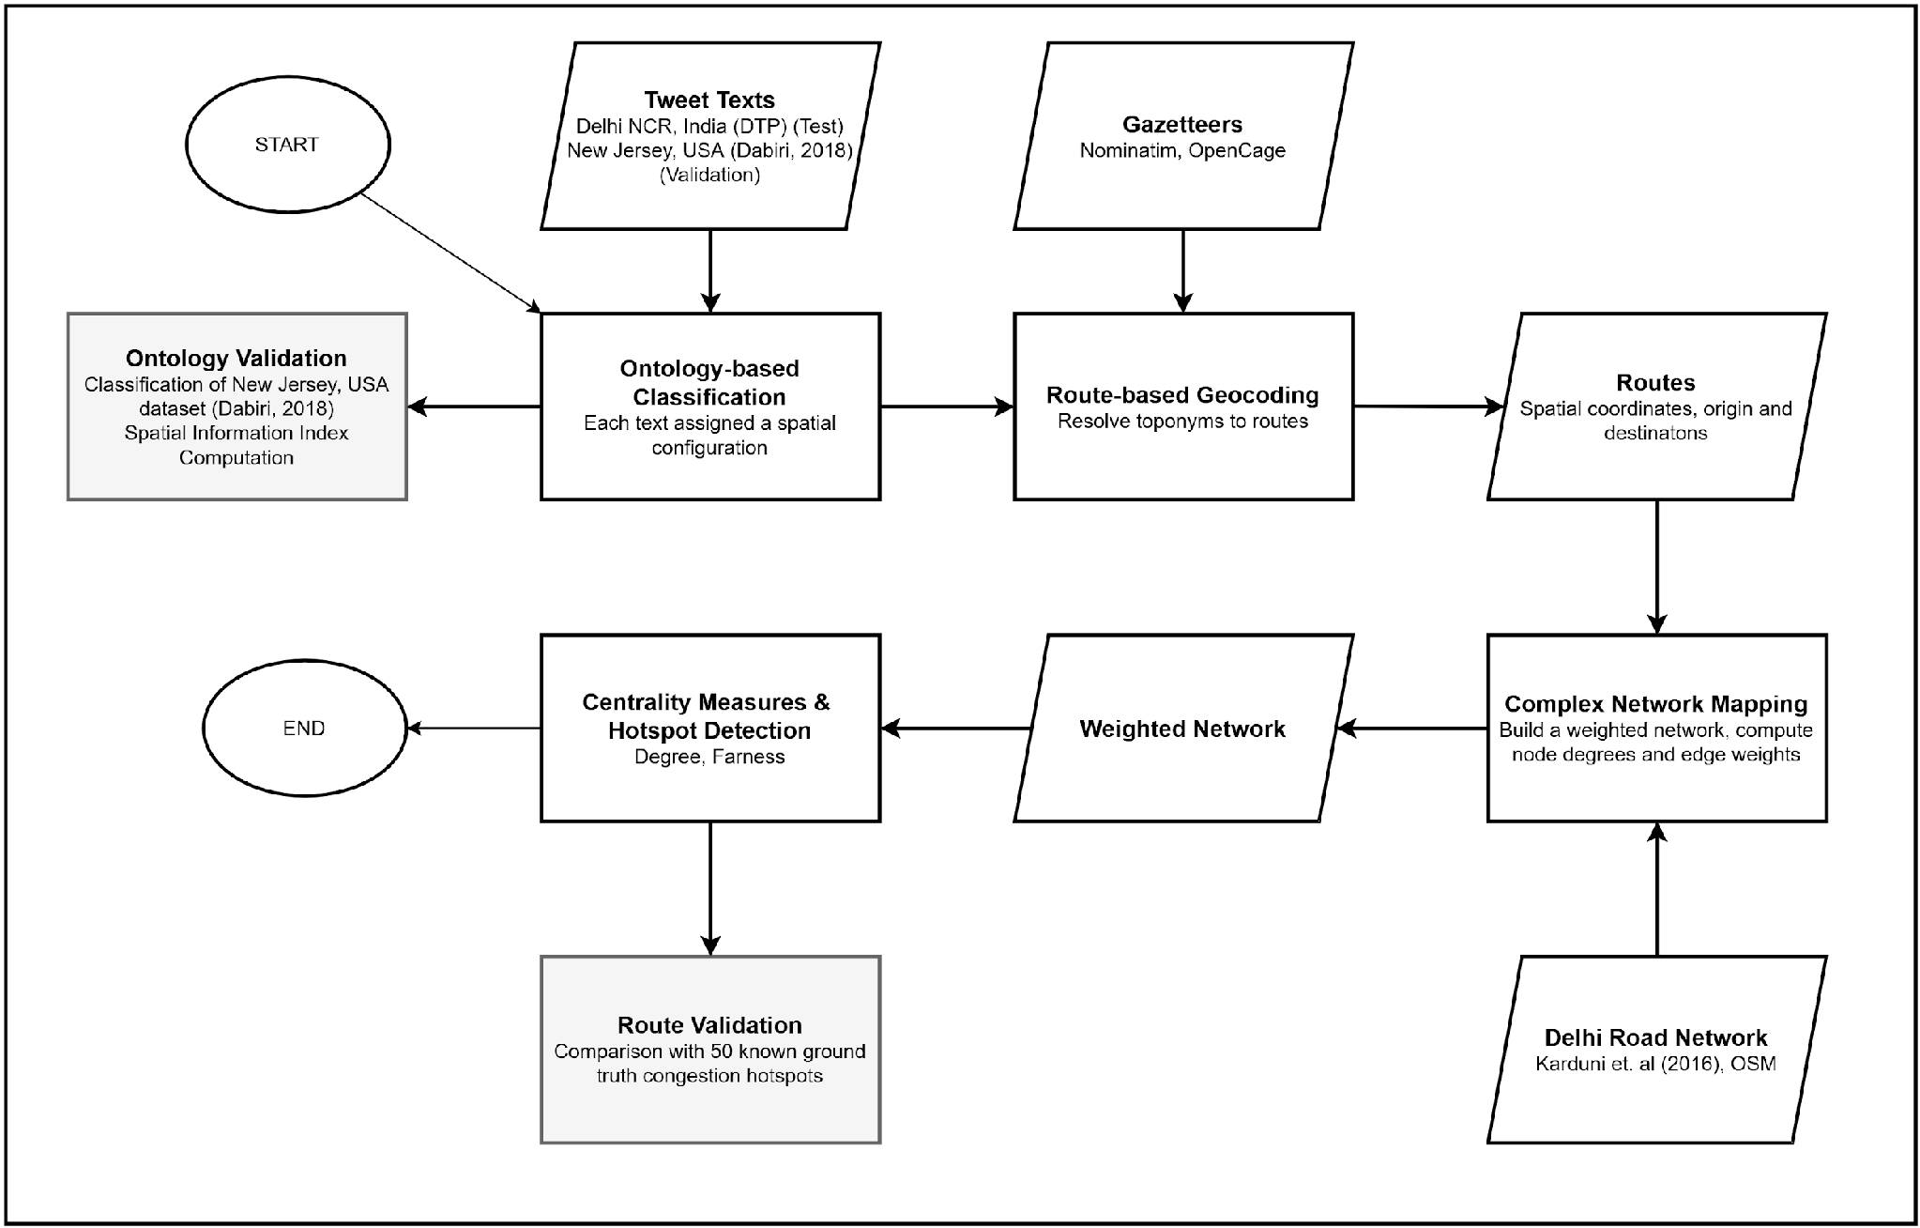
Figure 1: Overview of the methodology. Gray boxes represent validation steps.
Next, we outline our spatial configuration ontology and detail the geocoding and disambiguation strategy.

The Spatial Ontology
Stock (2014) has suggested an extensive geometric configuration ontology to support spatial querying for the general case of extracting location from natural language texts encompassing different types of spatial relations. Spatial configuration relations can be qualitatively characterized through concepts such as collocation, adjacency, direction, and parallel linear orientation (Stock, 2014). Collocation describes situations in which two or more spatial entities occupy the same or substantially overlapping spatial region, signifying spatial coincidence rather than separation. Adjacency refers to entities that are immediately next to one another, sharing a common boundary or surface without intervening space. Direction expresses a projective or vector-based relation between entities, indicating the relative orientation of one object with respect to another. Parallel linear orientation denotes a relation between elongated features whose main axes are aligned in the same general direction, maintaining consistent spacing and orientation without intersecting. Together, these qualitative relations provide a conceptual foundation for representing and reasoning about spatial configurations in geographic information systems (Stock, 2014).
We adapt Stock’s generalized ontology to the special case of traffic-related texts. In our ontology, we pay special attention to direction, collocation, adjacency, and linear orientation. Although other spatial relations may feature in traffic-related natural language texts, we find that these four relations occur most frequently. Using the ontology, we are able to assign more than 90% of the tweet texts in our corpus to a definite spatial configuration. Note that the configurations outlined below are adapted to serve an instrumental purpose in systematically categorizing the diverse types of spatial references found in traffic-related tweets. They are thus less abstract than a general-purpose geometric configuration ontology for spatial information retrieval. Table 1 presents the spatial ontology.
Configuration | Type | Depiction | Description
Point Location  P  Collocation, Adjacency | Primitive |  | Singular geographic locations. This is the most spatially ambiguous configuration containing a single isolated point location. Example: “Traffic Alert Traffic is now normal at Chirag Delhi.”
Multiple Point Locations  MP  Collocation, Adjacency | Complex |  | Multiple geographic locations without any spatial relationships amongst each other (Das and Purves 2020). Example: “Traffic is heavy near Patiala House Court and Saket Court.”
Line Location(s)  L  Parallel Linear Orientation | Complex |  | Linear geographic features like roads, streets, bridges, or underpasses. This configuration captures traffic flow along (or parallel to) the traffic-bearing linear structure like a road. Example: “Traffic on Kasturba Gandhi Marg is affected due to a candle march.”
Multiple Line Locations  ML  Parallel Linear Orientation | Complex |  | Multiple linear features. Example: “Avoid intersections at Outer Circle Connaught Place, Sansad Marg, Ashoka Road due to Tazia Procession.”
Origin  O  Collocation, Direction | Primitive |  | A starting point of a traffic event, such as "from" or "starting at" without a trajectory or endpoint. O is different from P since it also indicates an “outward” direction from an origin. However, O is still ambiguous about the particular direction of traffic flow. Example: “Traffic Alert Got from Patel Chowk P.O. Now traffic is normal.”
Destination  D  Collocation, Direction | Primitive | 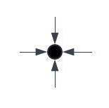 | An endpoint towards which traffic moves, defining the directionality of the flow. While "to" indicates a specific endpoint and "towards" implies movement in the general direction of a target, both contribute to defining the destination without referencing the origin. Example: “Traffic has been diverted towards Vasant Vihar due to water stress.”
Origin to Destination  O2D  Collocation, Direction | Complex | 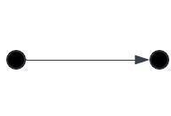 | Origin and destination paired through directional prepositions like "from" to "to." A set of probable spatial trajectories between two the origin and destination without disambiguation amongst the possibilities. Example: “Traffic is heavy from Inderlok to Shastri Nagar.”
Origin to Multiple Destinations O2MD  Collocation, Direction | Complex | 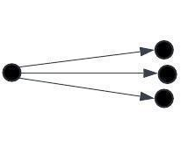 | Divergent traffic flows stemming from a common starting point. Example: “Traffic Alert Traffic is heavy from Inderlok to Zakhira and Kanhaiya Nagar due to weekly market.”
Origin to Destination at a Point  O2D@P Collocation, Direction | Complex | 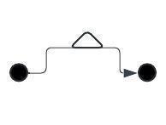 | An origin and a destination and collocation with a landmark point. Example: “Obstruction in traffic from Safdurjung Enclave towards IIT Flyover due to breakdown of a truck at Green Park.”
Origin to Destination along/on a Line O2DonL  Collocation, Direction | Complex |  | This specifies traffic flow from a specific origin to a specific destination point (O2D) on or along a specific pathway (L). Example: “Traffic movement on Sansad Marg in the carriageway from Patel Chowk towards Jantar Mantar is closed due to demonstration.”
Point on a Line PonL Collocation, Adjacency, Parallel Linear Orientation | Complex |  | This configuration identifies a landmark on or near a specific road. Example: “Water logging at Adchini on Aurobindo Marg. Kindly avoid this stretch. Inconvenience is regretted.”
Point and a Destination (P&D)  Collocation, direction. | Complex |  | A point with movement or flow from that point without a specific destination. Example: “Traffic Alert Traffic is now normal at Tilak Nagar towards Hari Nagar.”

Table 1: Spatial ontology
The configurations described in items 1-7 or some version of them are already documented in the literature (Wanichayapong et al. 2011). We introduce the 5 novel configurations (8-12) as in this work. We classify each configuration into “Primitive” or “Complex” where primitive configurations contain only spatial indicators of collocation while complex configurations contain additional spatial relationships (direction, adjacency and parallel linear orientation).

The Geocoder
The geocoder algorithm uses the spatial ontology to obtain the final geocoded route through the following stages.
- Ontology-based Classification
- Constraint Extraction
- Gazetteer Lookup and Snapping
- Spatial Query Construction
- Deterministic Route Selection
Ontology-based Classification
The process of classification of tweet texts, after cleaning and tokenization, begins with syntax parsing. We perform parts-of-speech (PoS) tagging to isolate grammatical structure. The classifier follows a rule-ordered, syntax-first approach. We detect directional prepositions ("from", "to", "towards"), locative prepositions ("at", "near", "under", "along", "on") and common prepositional bigrams (such as "starting at") using a dictionary. Toponym search is conducted within lexical spans adjacent to their governing prepositions. In traffic discourse, prepositions are the primary indicators of topological structure. We thus use prepositional cues to find candidate spatial relationships between entities, which are subsequently refined through network-based routing to infer their underlying topological configuration. This keeps the geocoding logic simple while still offering adaptability to other datasets as we show in the validation section.
The ontological classifier does not replace topology; rather, it determines which topological checks the geocoder should perform. Topology is enforced where it properly belongs - on the map. This separation of linguistic classification from spatial validation makes the method both reproducible and portable, while ensuring fidelity to the spatial relations that traffic language actually conveys.
At the classification stage, we identify toponyms based on the PoS tags but delay the resolution of place names to a later step. This allows us to apply the spatial ontology paying attention only to the spatial structure encoded by the text without reference to any particular geography. City-specific named entity recognition and gazetteer adaptations are applied later. Each tweet is assigned to exactly one configuration based on precedence.

We test for spatial configurations in a fixed order, starting from the spatially complex ones followed by the primitive ones. Route-bearing textual indicators that encode spatial relationships (such as O2D@P and O2DonL) are prioritized ahead of primitive configurations like P or L. This ordering reflects the design principle that richer spatial language should take precedence in classification. The ranking has been tuned to ensure that more specific spatial references are not overridden by generic pattern matches later in the sequence.

Constraint Extraction from Text
From the tweet text T and the spatial configuration K assigned in the classification step, we extract the origins, destinations, landmarks and linear features forming a "constraint" tuple C = (O, D, A, L), where:
- O: Origin seed (point), if the text includes from or starting at.
- D: Destination seed (point), if the text includes to or towards.
- A: Landmark anchors (points), if the text includes at, near, over, or beside.
- L: Named linear features like roads (lines), if the text includes on or along.
The constraint tuples are used to construct spatial geocoding queries to obtain the final routes. Note that the spatial configuration to which the text has been classified will determine the constraints that are detected in that particular text. For example, for the O2D configuration, we will have O and D. For O2D@P, we will have O and D and also add a landmark A. O2DonL will populate O and D, and add a named road L, and so on.

Gazetteer resolution and Snapping
A gazetteer is a structured geographical dictionary that provides standardized spatial references - such as coordinates, feature types, and administrative hierarchies - for named locations (Goodchild and Hill 2008). Gazetteers are essential in geocoding workflows because they enable the translation of place names mentioned in natural language text into precise spatial coordinates or geometries. In this study, all named entities identified in tweets are resolved through gazetteer lookup. Place names corresponding to discrete locations (e.g., intersections, landmarks) are mapped to point geometries, while road names and other linear features are resolved to line geometries derived from OpenStreetMap data. For each toponym, we use the ranking and confidence metrics returned by the gazetteer service to select the most probable match within the defined study boundary (Delhi). Bounding boxes associated with gazetteer entries are computed directly from the returned geometry or metadata and are used to constrain subsequent spatial queries. Once coordinates are obtained, origin (S), destination (D), and anchor (A) points are “snapped” to the nearest drivable network node or edge within a fixed radius using the OpenStreetMap road network. Snapping ensures topological consistency between the textual reference and the physical transport network. If the snapping process fails for any required spatial role, the tweet is marked as geocoding-infeasible and excluded from downstream routing analysis.

Spatial Query Construction
The spatial queries use two basic operations; geocode and route. The geocode operation takes a toponym as input and returns the spatial coordinates that it maps to on the geographical plane. The route operation takes as input two locations specified by their spatial coordinates and returns all possible routes between those locations as an ordered path containing the origin, destination, and intermediary waypoints. Finally, the geocoder outputs the most probable route(s) as ordered coordinate sequences (with origins, destinations, and optional intermediate constraints).
Table 2 shows the spatial query construction logic and route construction strategies for each configuration.
Configuration | Description | Geocoding Operation | Spatial Query Logic | Notes
P (Point) | Single-point configuration | geocode  one toponym | Returns a single coordinate point (no route) | Degenerate case – minimum spatial information
MP (Multi-Point) | Multiple toponyms but no directional indicators | geocode each toponym | Construct routes between each pair of points → nC₂ possible routes | High spatial uncertainty due to absence of spatial relationships
L (Linear) | Linear geographic feature (road, bridge, underpass) | Identify linear features from gazetteer (e.g., OSMnx) | Extract linear geometry corresponding to traffic-bearing structure | Represents traffic flow along a linear feature
ML (Multi-Linear) | Multiple linear features in a single configuration | geocode each toponym, extract its linear geometry | Combine geometries using set union of line segments | Produces a merged set of probable routes; captures multi-road structures
O (Origin) | Starting point known; endpoint unknown | geocode origin and bounding box (via OpenCage) | Generate all feasible routes emanating from the origin within a bounding box | Outbound flow; destination unknown
D (Destination) | Endpoint known; origin unknown | geocode destination | Generate all routes converging toward the destination within a bounding box | Inbound flow; origin unknown
O2D (Origin-to-Destination) | Standard dual-point configuration | geocode origin and destination | route query to obtain probable route between points | Provides most direct and likely traffic route
O2MD (Origin-to-Multiple-Destinations) | Single origin, multiple destinations | geocode origin and all destinations | Perform individual O2D queries for each destination, then union results | Captures flow network from one source to many sinks
O2D@P (Origin-to-Destination via Point) | Route constrained via an intermediate landmark | geocode origin, destination, and landmark | Execute route query with landmark as a waypoint | Reduces spatial ambiguity; landmark anchors the route
O2DonL (Origin-to-Destination on Linear Feature) | Route along a specified road | geocode origin and destination; extract road geometry | Project O and D to their nearest points on the named road, then trace route along the clipped road segment | Ensures trajectory follows specific named road; enhances precision
PonL (Point-on-Linear) | Point associated with a road | geocode point; access road geometry | Project the point to the road and identify two farthest points on the road in opposite directions, using geocoded point as waypoint | Constructs route passing through the point, preserving road continuity
P&D (Point-with-Direction) | Point and directional destination provided | geocode point and extract direction from text | From the point, use directional preposition (“towards”) to extrapolate a route along a direction | Encodes directional flow; aligns route with indicated movement

Table 2: Summary of Spatial Query Logic and Geocoding Operations for each Spatial Configuration

Spatial Disambiguation
Spatial disambiguation uses additional locative cues in text (e.g., landmarks, named roads, directional phrases) to constrain candidate routes. When only endpoints are given (e.g., 'from A to B'), multiple routes may be possible; when a road or landmark is mentioned (e.g., 'on Road L' or 'at P'), we treat it as a constraint (waypoint or clipping) to select a more plausible route segment. Figure 2 shows examples of spatial disambiguation. In Figure 2a, an example tweet reports an obstruction from Safdarjung Enclave towards IIT Flyover, located at Green Park. The landmark is used as a constraint so the routed path passes by the landmark rather than taking an alternative route that bypasses it. In 2b, an example tweet reports closure on Sansad Marg (a street) from Patel Chowk towards Jantar Mantar. The geocoder extracts the named road geometry and clips it to the segment between the two closest points to O and D on that road.
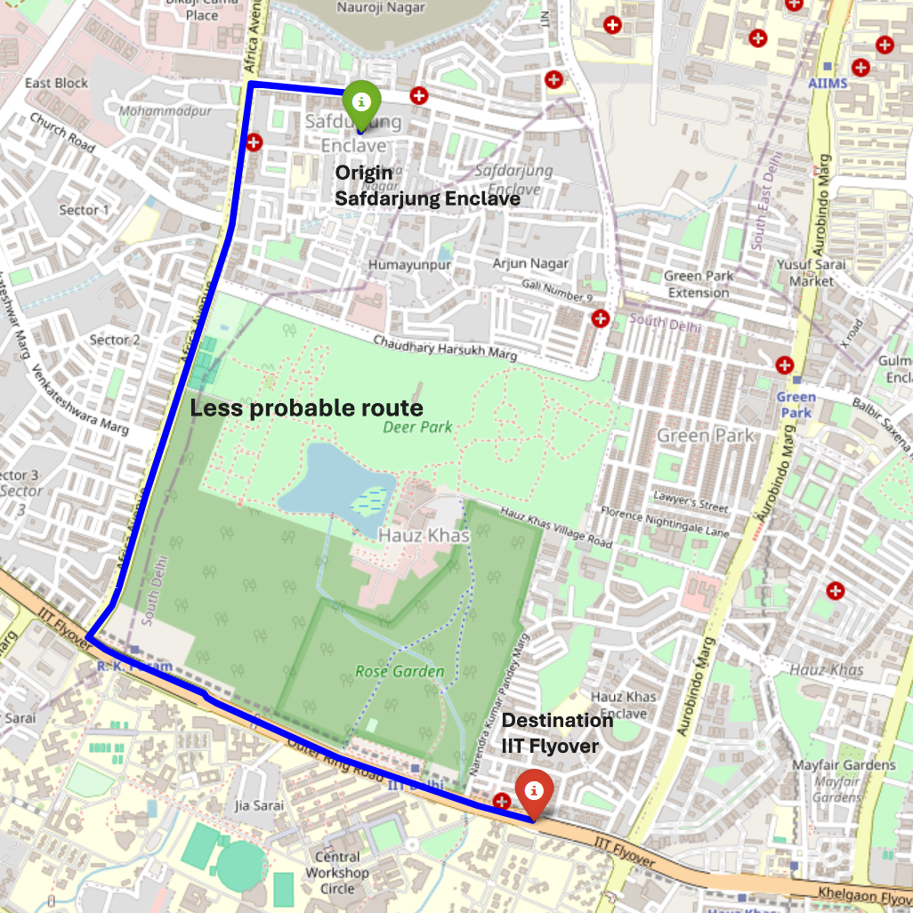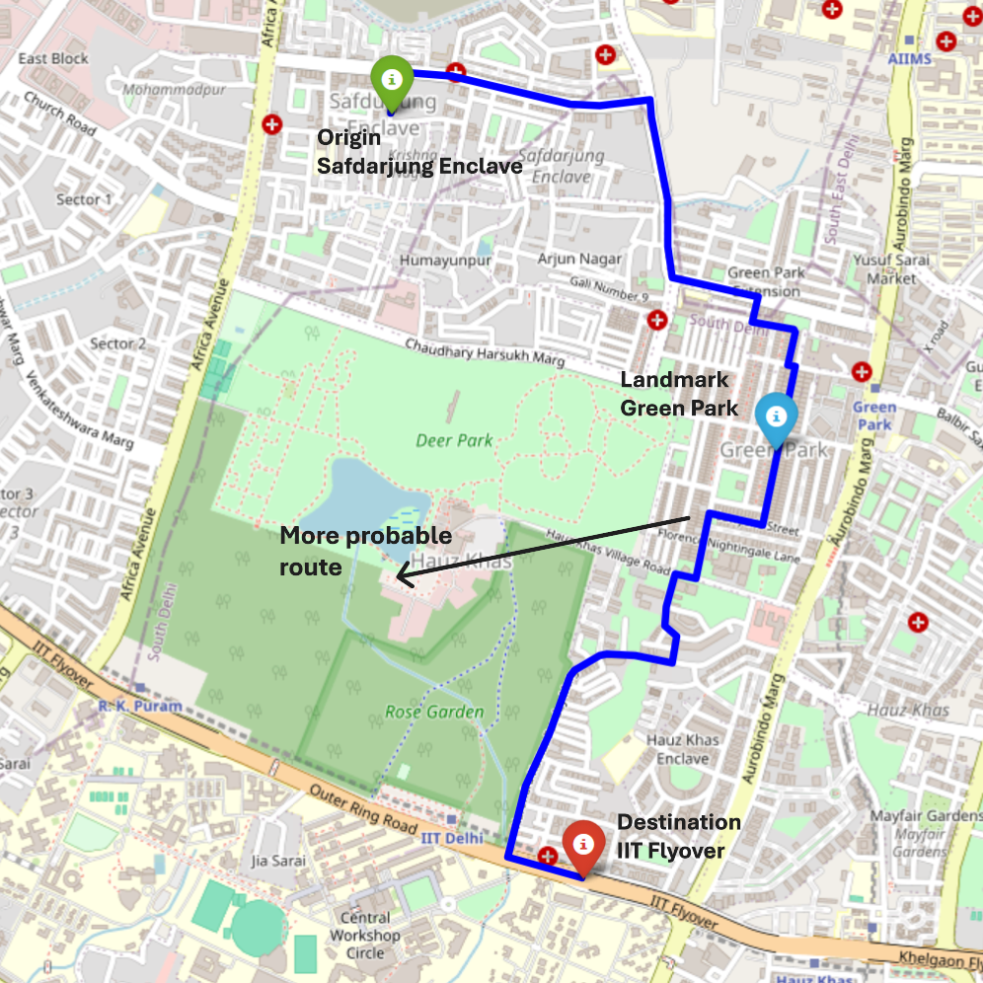Figure 2a: Spatial disambiguation (O2D@P).
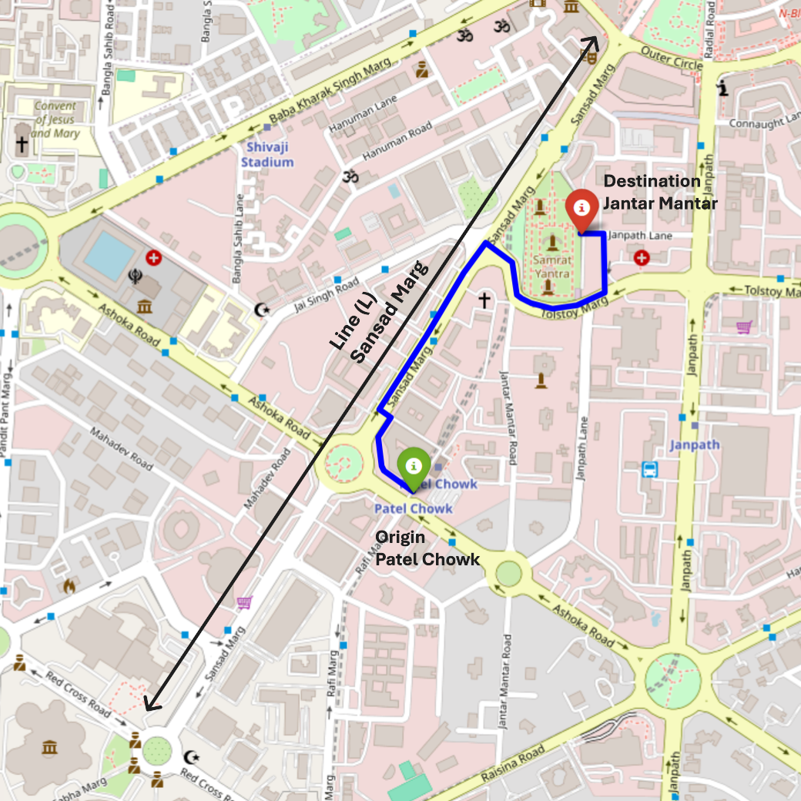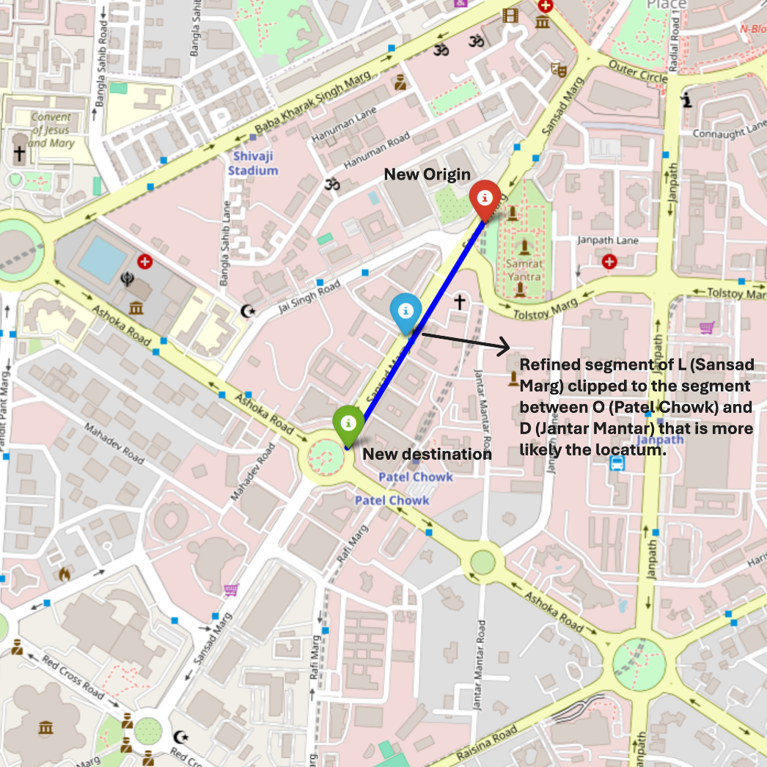Figure 2b: Spatial disambiguation (O2DonL).

The Complex Network Mapper
We represent the road system as a directed graph G=(V,E) where nodes are intersections and edges are road segments. After mapping each geocoded route to this graph, we aggregate route occurrences to assign edge weights that summarize the frequency of reported congestion alerts along segments.

Assigning Weights to Links Using Routes
We want the weight of each link in our complex network to be a measure of the congestion that was historically reported along that link. We define the weight $w_{i}$ of link i as the frequency of occurrence of a particular link on a congested route as geo-coded from a tweet. For example, if a particular link occurs in 8 geo-coded routes, the weight assigned to that link is simply 8. Now links with higher weights are those that were found to be more frequently the sites of traffic congestion relative to other links in the network.
We first set all of the weights in the network to zero. We then go through all the routes and detect for each route the set of nodes and links that lie on them. We keep a count of how many times each link appears in a route, using a dictionary to store the frequencies. If R is the set of all routes and r is any route then weight $w_{i}$ or link i is calculated as follows:
$w_{i}=\sum_{r}{}I(i∈r) ∀ r ∈R$
where I is an indicator function that equals 1 if link i appears in route r and zero otherwise.

Centrality Measures
We summarize congestion patterns on the road network using degree and farness centrality. In a directed network, degree can be split into in-degree and out-degree; it is a local measure based on incident edges.
Farness of a node is the sum of shortest-path distances from that node to all others it can reach (i.e., a measure of remoteness). Closeness is the inverse of farness.
$farness(u) =\sum_{v∈V,u!=v}{}dist(u,v)$
$dist(u,v)$. Here d(u,v) denotes the shortest-path distance between nodes u and v (unweighted: number of edges; weighted: sum of edge weights along the least-cost path).
Unweighted centrality reflects network structure (road connectivity). Weighted centrality incorporates reported congestion by treating edge weights as traversal cost (Newman 2001). We report unweighted and weighted forms to separate structural accessibility from congestion-affected accessibility; more complex hybrid measures (Opsahl et al. 2010) are left for future work.
Nodes with high weighted in-/out-degree lie on frequently reported congested routes and are treated as congestion hotspots. Weighted farness captures how much congestion is encountered when traveling from a node to the rest of the network. We normalize farness values by the maximum to aid comparison across maps.

Data
Twitter data: We prepared a tweet corpus containing 6682 tweets, the earliest one having been posted at 6:58 am on June 19th, 2014, and the latest one at 9:38 pm on June 5th, 2019, using the handle (@dtptraffic) dedicated to traffic alerts (Delhi Traffic Police n.d.). We removed punctuation marks, URLs, numbers, white spaces, and commonly used English words (then, are, is, etc.). We removed tweets that were duplicates, written in a non-English language, and those that had only non-textual information like images and links. After filtering, we were left with a corpus of a total of 5144 tweets made in an approximately 5-year period. Figure 3 visualizes the Twitter activity and the top 50 most frequent terms occurring in tweets between 2014 and 2019 from the @dtptraffic handle.
The selection of the Delhi Traffic Police (DTP) Twitter handle, @dtptraffic, as the primary data source for this research is informed by its established reliability, authenticity, and the targeted nature of its content. Tweets from this handle are explicitly focused on traffic-related incidents, eliminating the need for classification algorithms required to filter relevant information from general tweets, a problem outside the scope of this paper. The handle has robust engagement metrics, with over 1.5 million followers indicating the social utility and impact of the traffic data it provides. This aspect is crucial as it contributes to a community-driven approach to traffic management, where public interaction and compliance are integral to the effectiveness of traffic governance.
The literature on data mining from social media emphasizes the importance of source reliability and data relevance in traffic management studies (Osorio-Arjona et al. 2021, Serere et al. 2023). As noted in previous research, the use of data from official sources like city traffic handles reduces the uncertainty associated with the veracity and applicability of the information obtained, which is often a significant challenge when dealing with broader social media datasets (Goodchild and Glennon 2010).
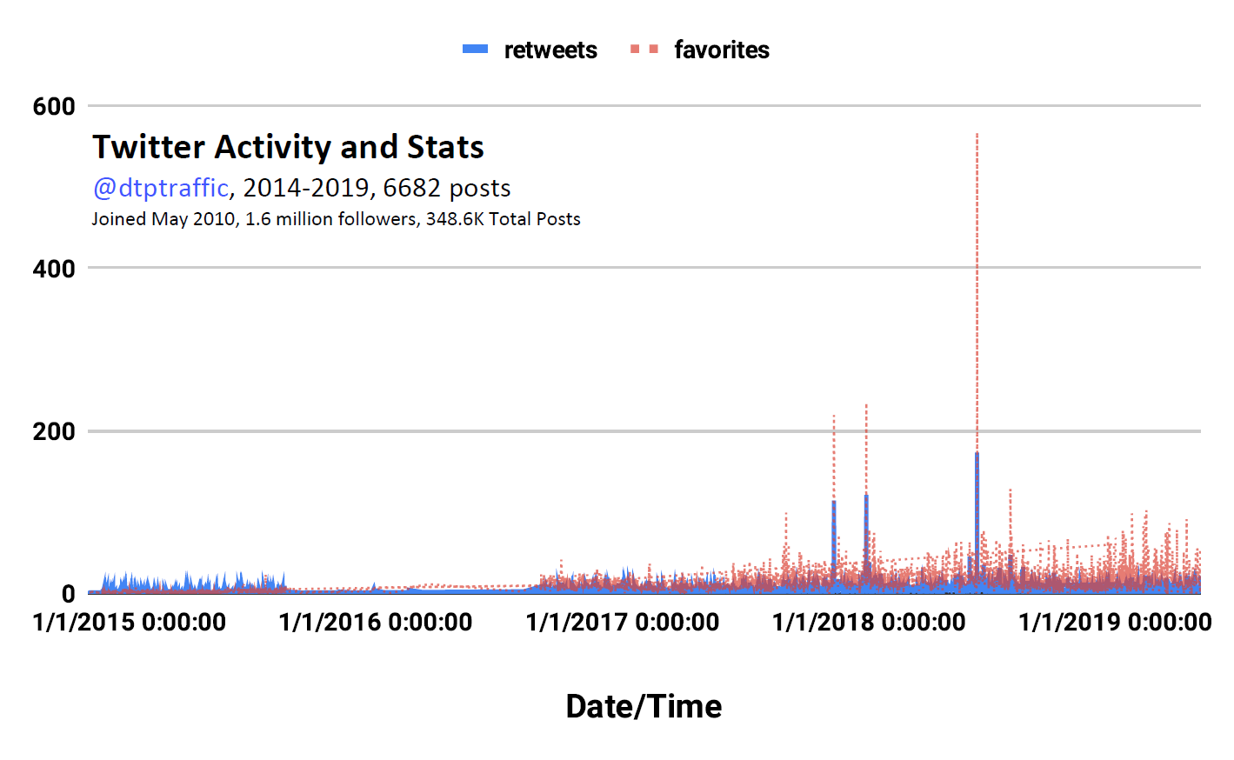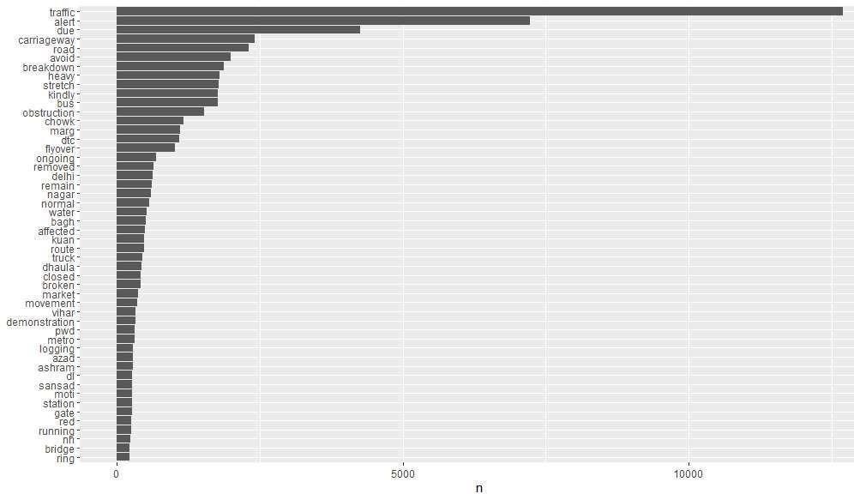
Figure 3: @dtptraffic Twitter activity chart (left) and Top 50 most frequent words (right), 2014-2019.
A complex network of roads for New Delhi: Karduni et al. (2016) have prepared a node-link complex network data structure for Delhi-NCR. They used the OSM road network as their base data which facilitates our study since we use the OSM service to geocode tweets. The road network has been partitioned into a set of nodes that correspond to major intersections and a set of links that correspond to the connecting roads between the intersections. The complex network data is available publicly and we use it to build our complex traffic congestion network (Karduni et al. 2016). The complex network is visualized in Figure 4.

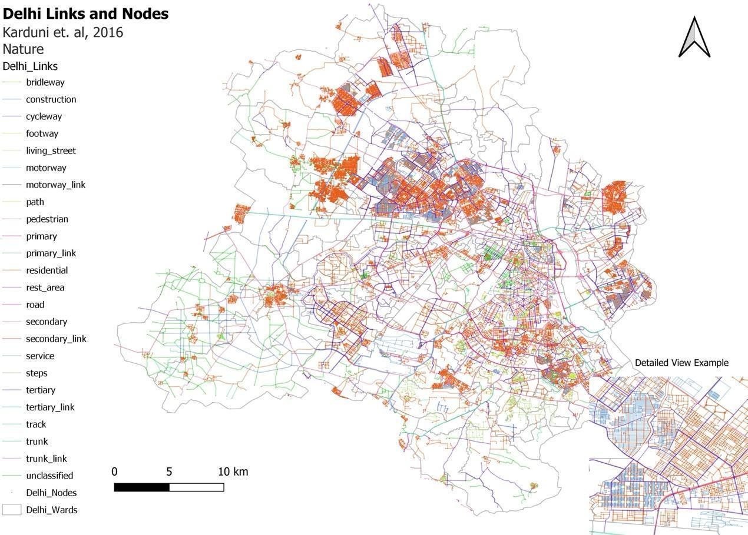
Figure 4: Complex network representation of the New Delhi road network (Karduni et al. 2016).

3 Results

Table 3 summarizes tweets by spatial configuration. Primitive P (points) accounts for 4.8% (246) and MP (multiple points) for 0.3% (18), while over 95% contain directional or flow cues. Novel configurations introduced here (O2MD, O2D@P, O2DonL, P&D, PonL) account for 35% (1790). Only 1.3% (69) remain uncategorized.
Configuration | Count of Tweets | Percentage
Point Location(s) (P) | 246 | 4.8
Multiple Point Locations (MP) | 18 | 0.3
Line Location(s) (L) | 803 | 15.6
Multiple Line Locations (ML) | 351 | 6.8
Origin(O) | 192 | 3.7
Destination(D) | 116 | 2.3
Origin to Destination (O2D) | 1559 | 30.3
Origin to Multiple Destinations (O2MD) | 108 | 2.1
Origin to Destination at a Point (O2D@P) | 1013 | 19.7
Origin to Destination along/on a Line (O2DonL) | 594 | 11.5
Point on a Line (PonL) | 21 | 0.4
Point and a Destination (P&D) | 54 | 1
Uncategorized | 69 | 1.5
Total | 5144 | 100
Table 3: Tweets classified in each geometric configuration.

Table 4 summarizes centrality statistics. The network has 152,727 links; only 7,073 (4.6%) receive non-zero weights, indicating reports are concentrated on a small set of arterial links (see Figure 5). This skew reflects both where congestion is reported and where police presence and reporting are concentrated, so unreported links should not be interpreted as congestion-free.
Centrality Measure | mean | median | max | min | std
Unweighted Degree | 2.83 | 3 | 9 | 0 | 0.86
Unweighted Farness | 0.58 | 0.58 | 1 | 0 | 0.12
Link Weights | 0.21 | 0 | 121 | 0 | 1.65
Weighted In-degree | 2.11 | 0 | 246 | 0 | 8.34
Weighted Out-degree | 2.12 | 0 | 246 | 0 | 8.36
Weighted Farness | 0.01 | 0 | 1 | 0 | 0.02
Table 4: Summary statistics of centrality measures. Farness measures normalized to the range [0,1].

The weighted in-degree and out-degree vary widely across the city (between 0 and 246) with most links having weighted degrees of 0 never being recorded as the site of probable congestion events. We computed the signed difference between the in-degree and the out-degree (in-degree minus out-degree) to delineate “sources” and “sinks” of traffic congestion. Nodes that have large negative values for the signed difference have much greater out-degrees than in-degrees and are the locations from where traffic mostly flows “out” whereas those with large positive values are “sinks” by similar reasoning. Figure 5 shows the spatial distribution of link weights and the signed difference of in-degree and out-degree. While the center of the city has both sources (red circles) and sinks (blue diamonds), the peripheral areas and the outskirts tend to be dotted by sources. This indicates that the overall “direction” of congestion is from outside of the city towards the center.
Link weights are indicated by red lines of increasing darker shades of red. The routes of high congestion are concentrated on the arterial roads and in the center. High congestion is recorded in the outskirts primarily in the Southern and Western parts of the city.
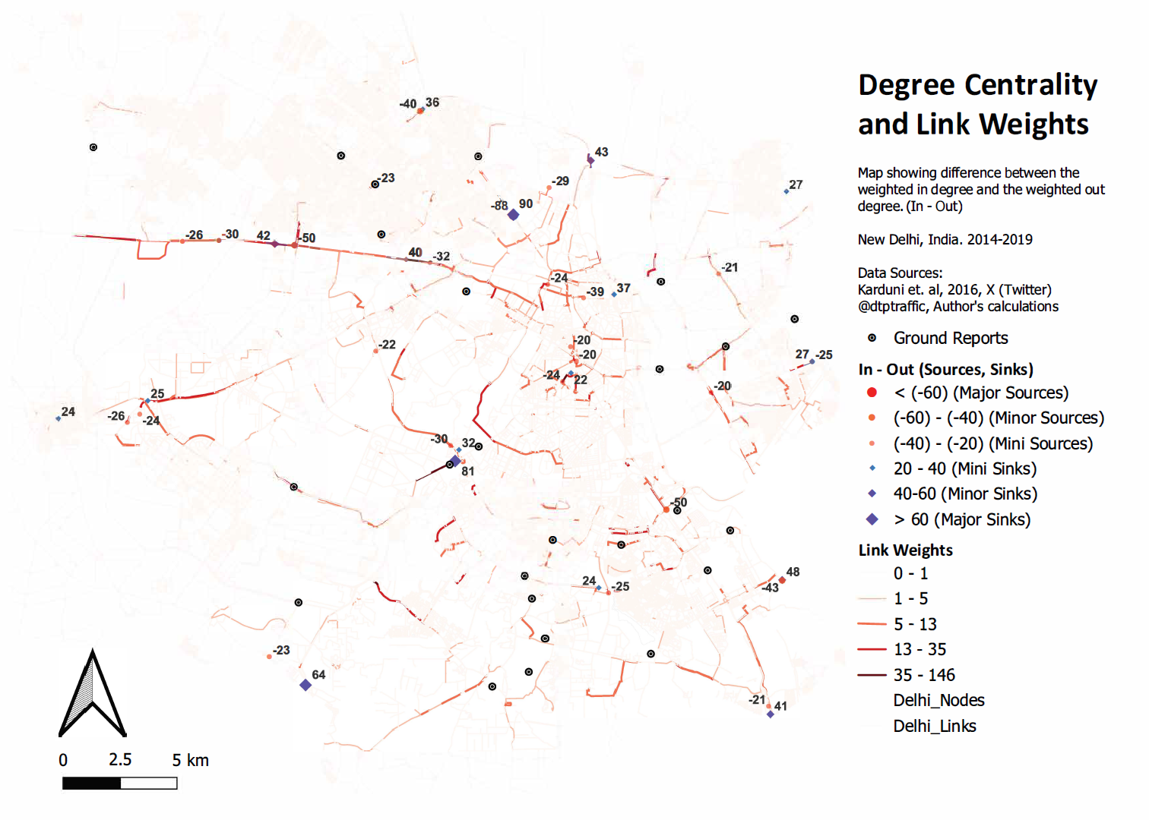
Figure 5: Degree centrality, link weights, sources and sinks along with ground reports of congestion.
Figure 6 maps normalized unweighted and weighted farness. Unweighted farness is lowest in central areas and increases outward, reflecting structural accessibility. Weighted farness is higher around central and major arterial nodes because frequent reported congestion along these corridors reduces effective accessibility when edge weights are considered.
Farness that is measured by congestion weights of links emphasizes the use of the road network in the face of dynamic congestion patterns as opposed to its structure. The weighted farness can also point towards possible policy interventions. A set of nodes located in the far south of the city have very high farness values because they are located near an arterial road that faces frequent congestion and they have no other alternative route through which they can access the city. Their access to the rest of the city is thus compulsorily mediated through a highly congested route, a clear case of a bottleneck. We argue that such an area is a site of possible policy intervention where providing an alternative means of access to the city for residents in the region can accrue large welfare benefits for a relatively smaller investment of public funds.
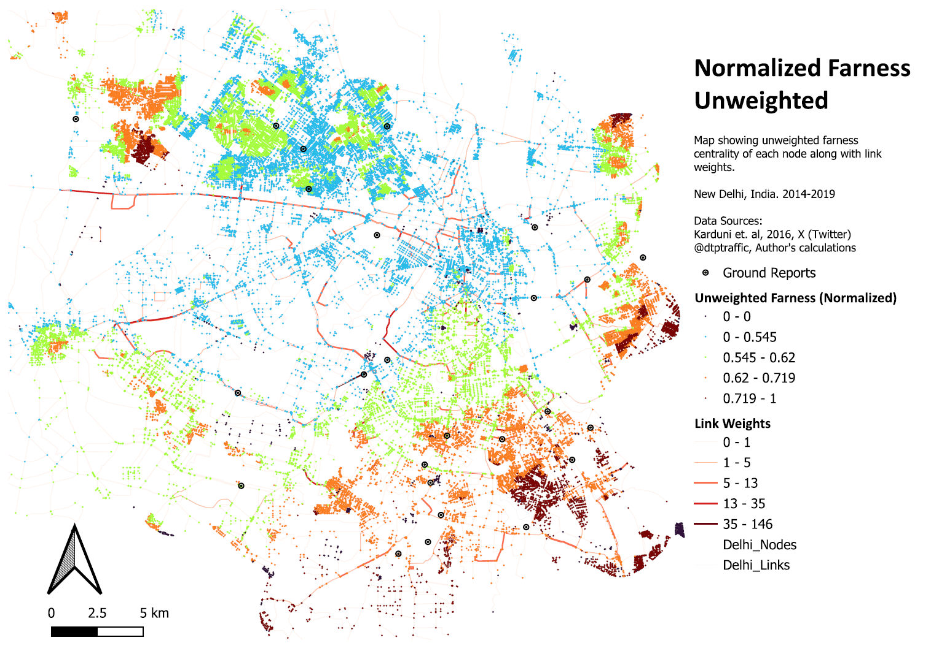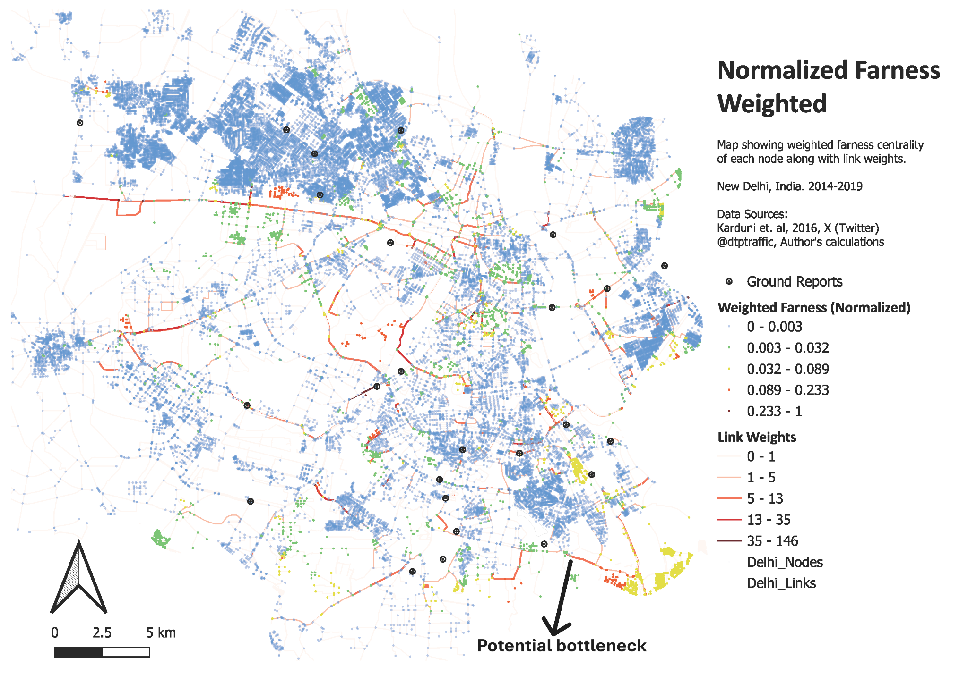Figure 6: Unweighted (top) and weighted (bottom) Farness Centrality

Validation of Results
We conducted two validation exercises: (i) to assess whether the spatial ontology generalizes beyond a single user and geography, and (ii) to assess whether aggregated, route-based geocoding outputs align with externally reported congestion hotspots.
Ontology generalizability was evaluated on a New Jersey (USA) dataset containing mixed traffic and non-traffic tweets from multiple users (Dabiri 2018). We classified each tweet into a spatial configuration without gazetteer lookup or route computation to test whether the ontology captures spatial language in a different region and writing style.
To quantify spatial content, we assign a spatial information score (SIS) to each configuration: Unclassified=0; primitive configurations (P, O, D)=0.5; and complex configurations (MP, L, ML, PonL, P&D, O2D, O2MD, O2D@P, O2DonL)=1. For a dataset with N tweets, the spatial information index (SII) is the normalized sum of SIS across all tweets. Higher SII indicates richer recoverable spatial structure.
Results (Table 5) support the hypothesis that traffic-related tweets contain more spatial information. The Delhi-NCR traffic dataset has SII=0.93. The New Jersey traffic subset has SII=0.85 (lower partly because it includes general advisories and rules in addition to event alerts). The New Jersey non-traffic subset has SII=0.34 (about 40% unclassified, 55% primitive, 5% complex; 3% in L). Across the two traffic datasets, only 1.3-6% of tweets remain unclassified, indicating broad coverage of spatial references.
Spatial Configuration | ID | Score | Traffic-related Tweets  Delhi NCR  (This work) |  | Traffic-related Tweets  New Jersey, USA  (Dabiri, 2018) |  | Non-traffic Related Tweets  New Jersey, USA (Dabiri, 2018)
(Type) |  |  | Count | SIS | Count (%) | SIS | Count | SIS
Unclassified | 0 | 0 | 69 (1.3%) | 0 | 1248 (6.1) | 0 | 7936 (39%) | 0
P (Primitive) | 1 | 0.5 | 246 (4.8%) | 123 | 3075 (15%) | 1537.5 | 5446 (26.6%) | 2723
MP (Complex) | 2 | 1 | 18 (0.3%) | 18 | 175 (0.9%) | 175 | 154 (0.8%) | 154
L (Complex) | 3 | 1 | 803 (15.6%) | 803 | 7197 (35%) | 7197 | 576 (2.8%) | 576
ML (Complex) | 4 | 1 | 351 (6.8%) | 351 | 5204 (25.4%) | 5204 | 47 (0.2%) | 47
O (Primitive) | 5 | 0.5 | 192 (3.7%) | 96 | 86 (0.4%) | 43 | 754 (3.7%) | 377
D (Primitive) | 6 | 0.5 | 116 (2.3%) | 58 | 595 (2.9%) | 297.5 | 5133 (25%) | 2566.5
O2D (Complex) | 7 | 1 | 1559 (30.3%) | 1559 | 498 (2.4%) | 498 | 207 (1%) | 207
O2MD (Complex) | 8 | 1 | 108 (2.1%) | 108 | 57 (0.3%) | 57 | 25 (0.1%) | 25
O2D@P (Complex) | 9 | 1 | 1013 (19.7%) | 1013 | 205 (1%) | 205 | 9 (0.04%) | 9
O2DonL (Complex) | 10 | 1 | 594 (11.5%) | 594 | 1900 (9.3%) | 1900 | 22 (0.1%) | 22
PonL (Complex) | 11 | 1 | 21 (0.4%) | 21 | 220 (1.1%) | 220 | 171 (0.8%) | 171
P&D (Complex) | 12 | 1 | 54 (1%) | 54 | 1 (~0%) | 1 | 0 (0%) | 0
 |  |  | Total = 5144 | SII = 0.93 | Total = 20461 | SII = 0.85 | Total = 20480 | SII = 0.34
Table 5: Spatial information indices for our Delhi NCR dataset, traffic-related tweets and non-traffic related tweets in the New Jersey, USA dataset.
To evaluate route outputs, we compared the density of geocoded alerts around 50 congestion hotspots published by Delhi Traffic Police (DTP 2019). For each ground-truth hotspot (GTH), we counted tweeted traffic alerts within a 1 km buffer. As a control, we sampled 50 random control points (RCP) in Delhi-NCR and computed the same 1 km counts (Figure 7).
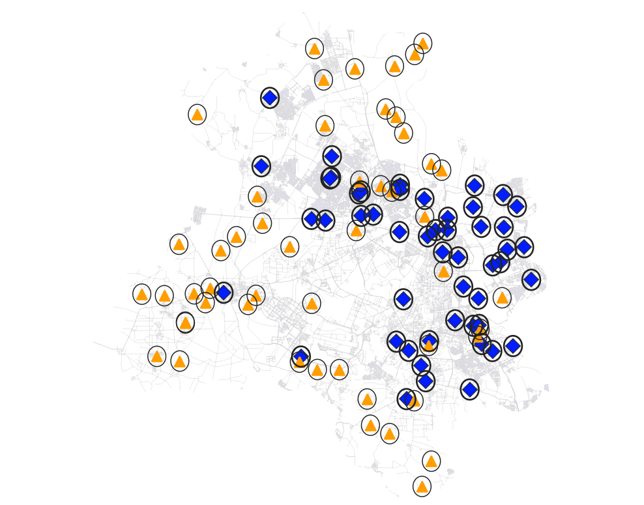
Figure 7: Ground Truth Hotspot (GTH) locations (blue diamonds) with 1 km buffer and random control points (RCP) (yellow triangles) with 1 km buffer.
A Welch t-test shows GTH buffers contain significantly more alerts than RCP buffers: GTH mean=102 (sd=124, N=50) vs RCP mean=33 (sd=111, N=50); mean difference=69 (SE=24), t(96)=2.92, p=0.0044, 95% CI [22, 115]. This provides statistical evidence that route-based geocoding concentrates reported alerts near known congestion hotspots (Figures 8-9).
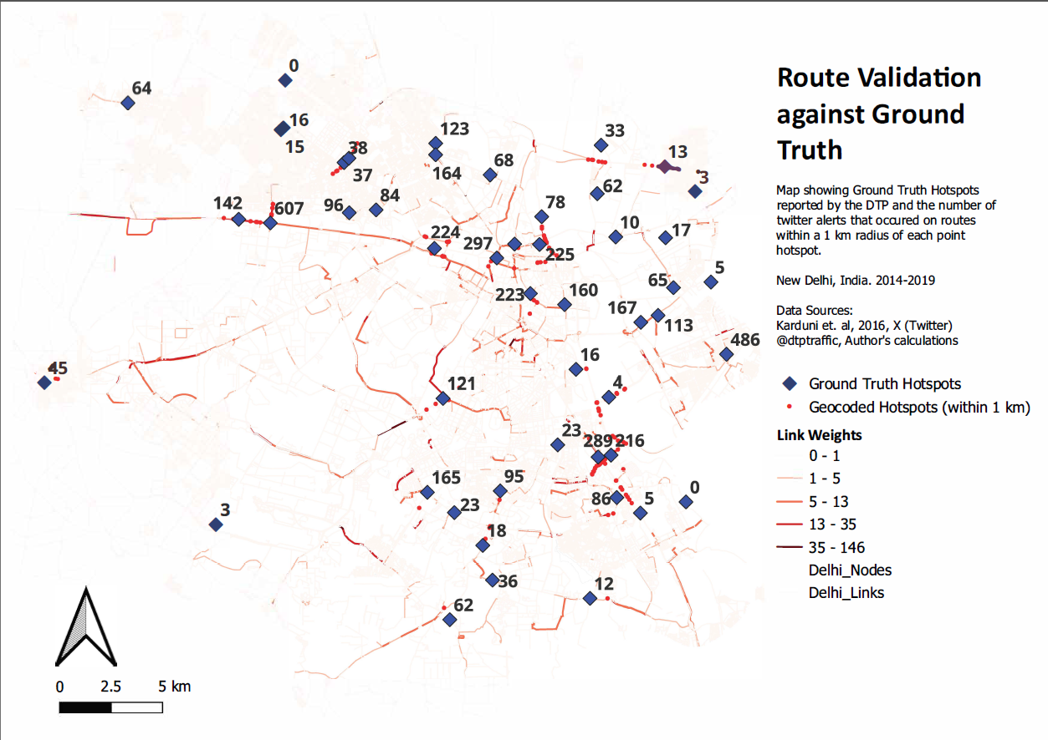
Figure 8: Route validation by comparing routes with ground truth point data.
Finally, Figure 9 illustrates the additional spatial detail provided by route-based geocoding relative to point hotspot data: within a 1 km buffer around an example hotspot, 121 alerts are distributed across specific road segments and directions, enabling segment- and intersection-level characterization (e.g., high weighted-degree intersections) and analysis of in/out-flow structure.
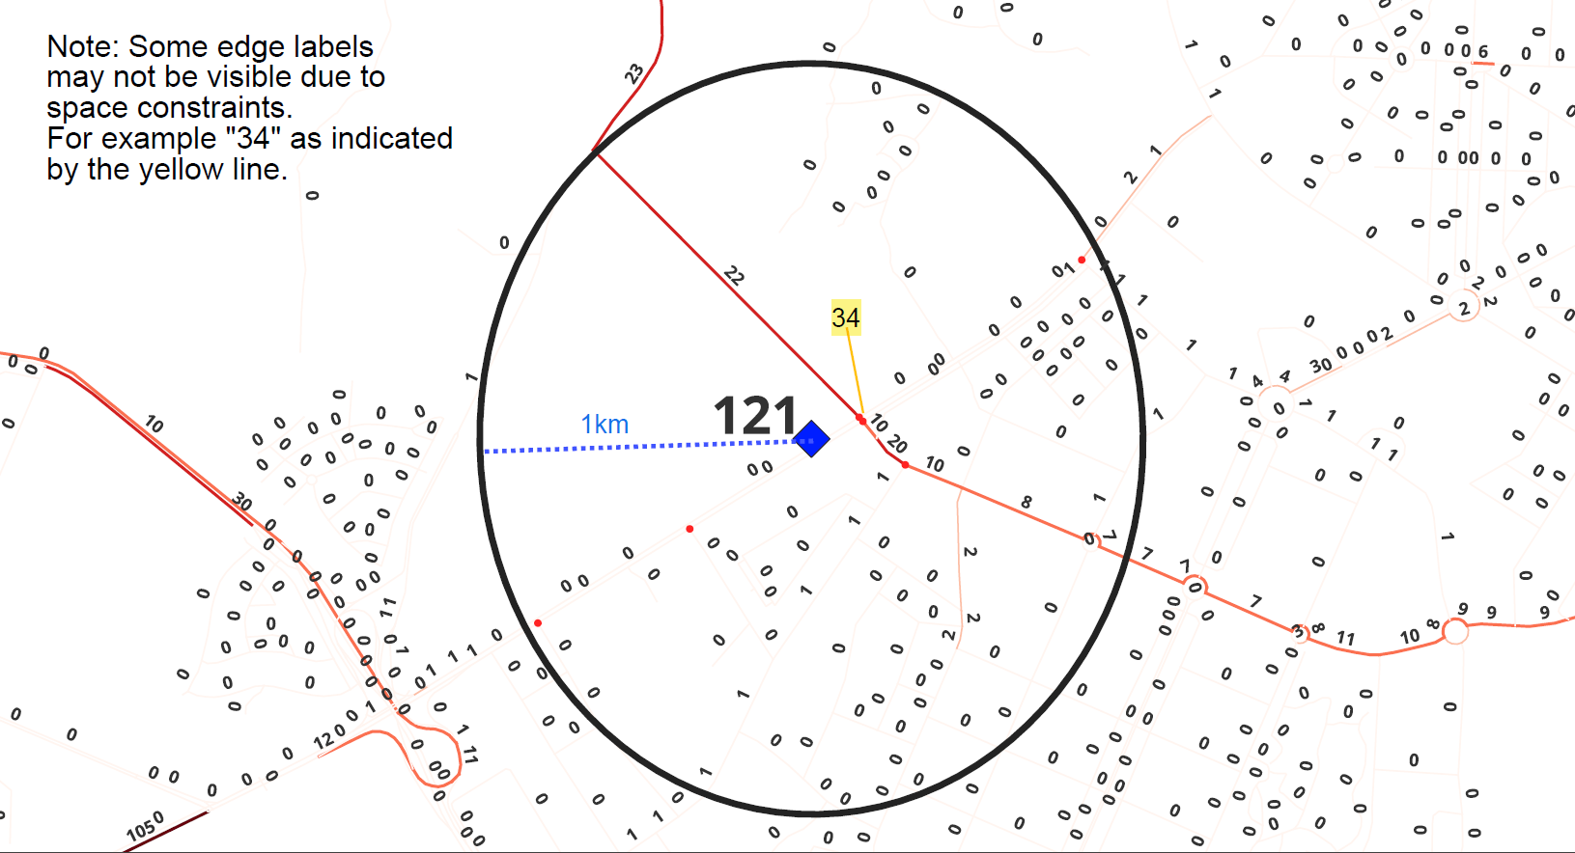
Figure 9: A ground truth hotspot (blue diamond) and the total number of tweeted traffic alerts in a 1 km radius of it (121). The figure also shows for each link in the road network, the number of congestion events that likely took place along it. Note that some link labels may not be visible due to lack of space.

4 Discussion
Our results demonstrate that the spatial language contained in traffic-related social media posts is far richer than what is currently being leveraged for movement and flow analysis. The proposed route-based geocoding approach effectively transforms this textual information into a complex network representation of urban traffic. Unlike passive sensor data, social media inputs originate from active human agents - commuters and/or officials reporting real conditions in real time - offering high contextual “quality.”
Spatially, central and high-income districts are overrepresented relative to suburban or low-income areas, and congestion events are more frequently documented at severe levels. Temporally, congestion alerts peak on Twitter between 8–11 a.m., whereas independent data from TomTom identifies evening peaks between 6–8 p.m. These discrepancies likely reflect differences in data collection, such as reduced police presence in the evening and in peri-urban and poorer neighborhoods leading to underreporting. These patterns suggest that while social media data capture real-time public perceptions of congestion, they also embed institutional and behavioral biases in where and when congestion is reported.
Broadening the scope of social media inputs beyond official handles to include citizen-driven traffic conversations can help mitigate these biases. Public participation in traffic governance—already evident in initiatives such as Bengaluru’s crowdsourced congestion mapping and community-based reporting platforms—demonstrates the feasibility of integrating bottom-up data into urban management. Despite unequal access to mobile technologies and social media that produces “data deserts” in marginalized neighborhoods, crowdsourced data remain a transparent, cost-effective, and scalable alternative to mass surveillance-based systems.
A route-based perspective on traffic information extraction is crucial for advancing data-driven traffic planning and management. Policymakers and transport analysts conceptualize traffic as a networked flow distributed across interconnected urban roads, and effective decision-making requires data that reflect these spatial dependencies. Point-based geocoding, by contrast, fragments this continuity and obscures directional flow. By reconstructing route-based spatial representations from social media texts, our approach captures the geometry and directionality of urban traffic as an integrated system, substantially enhancing the analytical and policy value of social media data in urban mobility studies.
The potential policy relevance of this framework is substantial. In 2015, the Indian Ministry of Urban Development called for low-cost methods to identify new “choke points” and alternative routes to decongest Delhi. Our study demonstrates that geocoded social media data can directly address these goals by using retrospective, publicly available data without requiring the installation of costly sensors or monitoring infrastructure. Unlike “intelligent transport systems” that rely on pervasive surveillance, a social media–based approach aligns with the principles of participatory governance and privacy-aware urban planning, offering an inclusive and adaptive model for data-driven mobility management.

5 Conclusion
We presented a route-based geocoding framework for traffic-related social media that treats the route (origin-destination with optional constraints) as the primary spatial primitive. Using a twelve-configuration spatial ontology and a syntactic analyzer, the system maps tweets to directed routes and aggregates them onto a road network to support complex-network analysis of reported congestion.
Applied to a five-year corpus of official traffic alerts for Delhi, route aggregation yields a weighted network that highlights frequently reported congested corridors and intersections and enables comparison between structural accessibility (unweighted measures) and congestion-affected accessibility (weighted measures). Validation shows the ontology generalizes to a multi-user dataset from a different region and that geocoded alert density is significantly higher around externally reported congestion hotspots than around random control locations.
The limitations of this paper include reliance on third-party routing to construct plausible paths, absence of per-route confidence scoring, and temporal aggregation of reports. Future work will incorporate confidence measures, alternative or multiple-route generation, and time-sliced analyses.

Disclosure statement
No competing interests declared.

Data Availability Statement
https://figshare.com/s/46d6ff39f575238ce686Data and code: https://figshare.com/s/46d6ff39f575238ce686

References
Agrawal, A. and Kuriakose, P.N., 2022. Implications of a Twitter data-centred methodology for assessing commuters’ perceptions of the Delhi metro in India. Computational Urban Science, 2 (1), 38.
Basu, A.J.R., Khatua, A., Ghosh, S., and Jana, A., 2017. Harnessing twitter data for analyzing public reactions to transportation policies: Evidences from the odd-even policy in Delhi, India. Proceedings of the Eastern Asia Society For Transportation Studies (EASTS).
Canon, G., 2018. ‘City of surveillance’: privacy expert quits Toronto’s smart-city project — theguardian.com.
Dabiri, S. (2018). Tweets with traffic-related labels for developing a Twitter-based traffic information system. [Dataset]. Mendeley Data. https://doi.org/10.17632/c3xvj5snvv.1
Das, R.D. and Purves, R.S., 2020. Exploring the Potential of Twitter to Understand Traffic Events and Their Locations in Greater Mumbai, India. IEEE Transactions on Intelligent Transportation Systems, 21 (12), 5213–5222.
Dash, D. K. (2017). Delhi traffic chaos costs Rs 60,000 crore annually. Times of India.
Delhi Traffic Police, n.d. Tweets and Replies, [Twitter profile]. Tweets and Replies.
Delhi Traffic Police, n.d. Traffic Congestion Areas | delhitrafficpolice — traffic.delhipolice.gov.in.
Ding, R., Ujang, N., Hamid, H.B., Manan, M.S.A., Li, R., Albadareen, S.S.M., Nochian, A., and Wu, J., 2019. Application of complex networks theory in urban traffic network researches. Networks and Spatial Economics, 19, 1281–1317.
Escamilla, I., Torres-Ruiz, M., Moreno-Ibarra, M., Quintero, R., Guzmán, G., and Luna-Soto, V., 2016. Geocoding Tweets Approach Based on Conceptual Representations in the Context of the Knowledge Society. International Journal on Semantic Web and Information Systems (IJSWIS), 12 (1), 44–61.
Estrada, E., 2012. The structure of complex networks: theory and applications. Oxford University Press, USA.
Fontes, T., Murços, F., Carneiro, E., Ribeiro, J., and Rossetti, R.J.F., 2023. Leveraging Social Media as a Source of Mobility Intelligence: An NLP-Based Approach. IEEE Open Journal of Intelligent Transportation Systems, 4, 663–681.
Goodchild, M.F. and Glennon, J.A., 2010. Crowdsourcing geographic information for disaster response: a research frontier. International Journal of Digital Earth, 3 (3), 231–241.
Gu, Y., Qian, Z. (Sean), and Chen, F., 2016. From Twitter to detector: Real-time traffic incident detection using social media data. Transportation Research Part C: Emerging Technologies, 67, 321–342.
Hou, S., Zhao, A., Liang, J., Shen, Z., and Wu, H., 2025. Geo-FuB: A method for constructing an Operator-Function knowledge base for geospatial code generation with large language models. Knowledge-Based Systems, 319, 113624.
Hu, X., Elßner, T., Zheng, S., Serere, H.N., Kersten, J., Klan, F., and Qiu, Q., 2024. DLRGeoTweet: A comprehensive social media geocoding corpus featuring fine-grained places. Information Processing & Management, 61 (4), 103742.
Hu, X., Kersten, J., and Klan, F., 2025. Scalable Toponym Resolution with LLMs: Accuracy and Speed Optimizations. Presented at the GeoExT 2025: Third International Workshop on Geographic Information Extraction from Texts at ECIR 2025.
Imai, K. and Bougher, L.D., 2021. Quantitative Social Science: An Introduction in Stata. Princeton University Press.
Karduni, A., Kermanshah, A., and Derrible, S., 2016. A protocol to convert spatial polyline data to network formats and applications to world urban road networks. Scientific Data, 3, 160046.
Ministry of Urban Development, G., 2016. Report of the High Powered Committee On Decongesting Traffic IN Delhi.
Newman, M.E.J., 2001. Scientific collaboration networks. II. Shortest paths, weighted networks, and centrality. Phys. Rev. E, 64 (1), 016132.
Opsahl, T., Agneessens, F., and Skvoretz, J., 2010. Node centrality in weighted networks: Generalizing degree and shortest paths. Social Networks, 32 (3), 245–251.
Osorio-Arjona, J., Horak, J., Svoboda, R., and García-Ruíz, Y., 2021. Social media semantic perceptions on Madrid Metro system: Using Twitter data to link complaints to space. Sustainable Cities and Society, 64, 102530.
Porta, S., Crucitti, P., and Latora, V., 2006. The Network Analysis of Urban Streets: A Primal Approach. Environment and Planning B: Planning and Design, 33 (5), 705–725.
Putra, P.K., Mahendra, R., and Budi, I., 2022. Traffic and road conditions monitoring system using extracted information from Twitter. Journal of Big Data, 9 (1), 65.
Rani, S., Kataria, A., Chauhan, M., Rattan, P., Kumar, R., and Sivaraman, A.K., 2022. Security and Privacy Challenges in the Deployment of Cyber-Physical Systems in Smart City Applications: State-of-Art Work. Materials Today: Proceedings, 62, 4671–4676.
Robbins, J., 2021. Why the Luster on Once-Vaunted ‘Smart Cities’ Is Fading — e360.yale.edu.
Salazar-Carrillo, J., Torres-Ruiz, M., Davis Jr, C. A., Quintero, R., Moreno-Ibarra, M., & Guzmán, G., 2021. Traffic congestion analysis based on a Web-GIS and data mining of traffic events from Twitter. Sensors, 21(9), 2964.
Serere, H.N., Resch, B., and Havas, C.R., 2023. Enhanced geocoding precision for location inference of tweet text using spaCy, Nominatim and Google Maps. A comparative analysis of the influence of data selection. PLOS ONE, 18 (3), 1–19.
Sharma, P., Samal, A., Soh, L.-K., and Joshi, D., 2024. A Spatially-Aware Data-Driven Approach to Automatically Geocoding Non-Gazetteer Place Names. ACM Transactions on Spatial Algorithms and Systems, 10 (1), 1–34.
Sonnemaker, T., 2021. Texas power companies automatically raised the temperature of customers’ smart thermostats in the middle of a heat wave — businessinsider.in.
Stock, K., 2014. A Geometric Configuration Ontology to Support Spatial Querying.
Stock, K., 2018. Mining location from social media: A systematic review. Computers, Environment and Urban Systems, 71, 209–240.
TNN Times of India, 2023. #Unjam campaign: Got a traffic pain point? Pin it on map, drive change.
Wanichayapong, N., Pruthipunyaskul, W., Pattara-Atikom, W., and Chaovalit, P., 2011. Social-based traffic information extraction and classification. In: 2011 11th International Conference on ITS Telecommunications. Presented at the 2011 11th International Conference on ITS Telecommunications (ITST), St. Petersburg, Russia: IEEE, 107–112.
Xu, S., Li, S., Huang, W., and Wen, R., 2022. Detecting spatiotemporal traffic events using geosocial media data. Computers, Environment and Urban Systems, 94, 101797.
Yao, W. and Qian, S., 2021. From Twitter to traffic predictor: Next-day morning traffic prediction using social media data. Transportation Research Part C: Emerging Technologies, 124, 102938.
Yin, Z., Li, D., and Goldberg, D.W., 2023. Is ChatGPT a game changer for geocoding - a benchmark for geocoding address parsing techniques. In: Proceedings of the 2nd ACM SIGSPATIAL International Workshop on Searching and Mining Large Collections of Geospatial Data. New York, NY, USA: Association for Computing Machinery, 1–8.
Zhang, M., Huang, T., Guo, Z., and He, Z., 2022. Complex-network-based traffic network analysis and dynamics: A comprehensive review. Physica A: Statistical Mechanics and its Applications, 607, 128063.
Zwarts, J., 2017. Spatial semantics: Modeling the meaning of prepositions. Language and Linguistics Compass, 11 (5), e12241.

Appendix A

Implementation-Specific Details of the Geocoder
We implement a complete geocoding and routing pipeline that transforms raw tweet text into structured geospatial data representing probable traffic routes. We integrate natural language processing, geocoding APIs, and routing services to extract spatial configurations, classify toponyms, and generate route geometries. The workflow includes nine main stages: initialization, data loading, toponym recognition, preposition classification, geocoding, routing, fallback geocoding, OSM-based refinement, and output generation.

1. Data Loading and Configuration
The pipeline begins by loading:
- A dataset of traffic-related tweets from Delhi containing tweet IDs, text, and timestamps.
- A Delhi-specific gazetteer compiled from the BBBike OpenStreetMap extract, listing both gazetted and non-gazetted places, road names, and landmarks.
- Configuration parameters such as Delhi’s bounding box and API keys for OpenCage (for geocoding) and OpenRouteService (for routing).
All data are loaded into pandas DataFrames or dictionaries. The bounding box limits every spatial query to Delhi’s region to minimize false matches.

2. Toponym Recognition with a Custom NLP Model
We load a customized SpaCy model fine-tuned for recognizing Delhi-specific toponyms. This step has to be customized for every geography. The model extends SpaCy’s standard NER classes to identify:
- LOC – general locations,
- GPE – geopolitical entities (neighbourhoods, districts),
- FAC – facilities (bridges, underpasses, junctions),
- ORG – organizations used as spatial markers.
Each tweet is processed to produce tokens, POS tags, and entity spans. Recognized entities are cross-checked against the BBBike gazetteer to confirm that they refer to real places within Delhi and to eliminate generic or ambiguous terms.

3. Preposition Extraction and Spatial Configuration Detection
Prepositions are extracted to determine spatial relationships expressed in the tweet text. Directional prepositions such as “from”, “to”, “towards”, and “starting at” indicate motion, while locative prepositions such as “at”, “near”, “under”, and “beside” indicate spatial proximity (Zwarts, 2017). The algorithm identifies each preposition, checks whether it is directional or locative (including bigrams like “starting at”), and associates nearby entities with appropriate spatial roles:
- Entities following directional prepositions like “from” become origins.
- Those following “to” or “towards” become destinations.
- Entities following locative prepositions like “at” or “near” become landmarks.
Based on the number and roles of detected entities, each tweet is assigned one of twelve spatial configurations (P, MP, L, ML, O, D, O2D, O2MD, O2D@P, O2DonL, PonL, P&D). This classification governs how geocoding and routing are performed in later stages.

4. Geocoding with OpenCage
For every identified toponym, the notebook sends a request to the OpenCage API to retrieve its latitude, longitude, and bounding box. Each request is bound to Delhi and filtered by the country code “IN”. The API response provides coordinates, bounding box, and a confidence score. These data are stored in a GeoDataFrame containing: tweet ID, toponym, role, latitude, longitude, confidence, and data source. If OpenCage fails or returns low confidence, the system triggers a fallback procedure using Nominatim.

4. Geocoding Process with OpenCage and OSM Source
Geocoding in this study was performed using the OpenCage Geocoder, which aggregates multiple gazetteer sources, including OSM, to resolve toponyms extracted from tweets. OSM provides the foundational geographic entities—roads, intersections, neighbourhoods, and administrative features, against which each textual location is resolved. For every toponym identified in the syntactic configuration stage, the system constructs a query string containing the detected place name, the city, and country. Each query is sent to the OpenCage API with the bounding parameter fixed to the Delhi NCR and the country code “IN” - for India. This ensures that toponyms are resolved only within the intended region, preventing false matches in other regions.
The API response returns:
- Geographic coordinates (latitude, longitude) of the resolved place,
- Bounding box defining its spatial footprint,
- A confidence score (0–10) indicating positional certainty,
- The underlying data source, most often OSM.
Each response is parsed and stored in a GeoDataFrame containing the following attributes:
[tweet_id, toponym, role (origin/destination/anchor/linear), latitude, longitude, confidence, data_source].
When OpenCage fails to return a result, a fallback routine automatically triggers a direct query to Nominatim, the native OSM geocoder, using the same bounding and filtering parameters. This ensures continuity of coverage while maintaining consistency with the OSM data model.
Integration with route construction.
The retrieved coordinates are then projected onto the OSM road network. Origin (S), destination (D), and anchor (A) points are snapped to the nearest drivable nodes or edges within a fixed search radius (typically 200 m). Linear features (L) such as highways or expressways are retrieved directly from OSM’s highway=* and route=* attributes. These elements collectively form the constraint tuple C=(S,D,A,L)C = (S, D, A, L)C=(S,D,A,L) for subsequent routing via the OpenRouteService API, which itself is built on OSM road geometry.
This design keeps the data provenance fully within the OSM ecosystem—OpenCage for gazetteer resolution, Nominatim as fallback, and OpenRouteService for network routing—ensuring reproducibility and transparency of all spatial entities derived from open data

5. Route Construction with OpenRouteService
The OpenRouteService Directions API is used to compute probable routes between geocoded points.
- For a single point (P), only a coordinate is returned.
- For multiple points (MP), all pairwise combinations are routed (nC2 routes).
- For O2D, one route between origin and destination is retrieved.
- For O2D@P, a landmark is inserted as a waypoint to force the route through it.
- For O2MD, multiple origin-to-destination routes are computed and merged.
- For linear configurations (L, ML, O2DonL), routes are drawn along OSM-derived road geometries instead of simple point-to-point interpolation.
Each route query specifies the “driving-car” profile and returns GeoJSON geometry, which is converted to shapely LineStrings and stored with metadata.

6. Fallback Geocoding with Nominatim
If OpenCage cannot resolve a location, Nominatim (based on OpenStreetMap) is queried to obtain an approximate bounding box.
- The algorithm then constructs a synthetic route using the southwest and northeast corners of the bounding box.
- This provides an estimated linear representation of the area when precise coordinates are unavailable, ensuring complete spatial coverage of all tweets.

7. Integration with OpenStreetMap for Linear Features
For configurations that reference roads or other linear structures, the notebook retrieves the actual geometry from OpenStreetMap using OSMnx.
- Queries such as “highway=True” extract road features within the Delhi bounding box.
- The geometry nearest to the geocoded point is selected as the relevant road segment.
- In multi-linear cases, multiple segments are merged using geometric union operations to represent complex structures like flyovers or interchanges.

8. Post-processing
The finally selected routes are merged where appropriate, and exported as GeoJSON and CSV summaries. The SpaCy model is saved for reuse in subsequent analyses. The geocoder system simultaneously leverages both directional and locative prepositions to extract fine-grained spatial relationships from tweet text, allowing it to interpret movement (e.g., “from”, “to”, “towards”) as well as proximity and positional context (e.g., “at”, “near”, “under”, “beside”). It integrates data from OpenCage, OpenRouteService, and OpenStreetMap (OSM) to perform robust and context-aware route estimation, combining geocoding precision with realistic network-based routing. A fallback mechanism using Nominatim ensures spatial coverage even when certain locations are ambiguous or unavailable through primary services. The entire framework is modular and extensible, enabling each component—toponym recognition, spatial classification, geocoding, routing, and post-processing—to be executed or updated independently for scalability and adaptability in different geographic or linguistic contexts.

Pseudocode Listing for the Geocoder Pipeline
INPUTS:
• tweets.csv – traffic tweets dataset
• delhi_gazetteer.csv – BBBike-derived list of Delhi toponyms
• DELHI_BBOX – bounding box coordinates for Delhi
• OPENCAGE_KEY, ORS_KEY – API credentials
FUNCTIONS:
process_text(text) → tokens, pos_tags, entities
classify_prepositions(tokens) → list of (prep, type)
identify_roles(preps, entities) → origin, destination, landmark
determine_configuration(roles) → configuration_code
geocode_opencage(query) → (lat, lon, bbox, confidence)
geocode_nominatim(query) → bbox
get_route_ors(origin, destination, profile='driving-car') → LineString
get_osm_geometry(name) → LineString
merge_routes(routes) → LineString
compute_confidence(meta) → score
PIPELINE:
- Load tweets and gazetteer.
- For each tweet:
a. tokens, pos, entities ← process_text(tweet.text)
b. preps ← classify_prepositions(tokens)
c. roles ← identify_roles(preps, entities)
d. config ← determine_configuration(roles)
e. store entities and configuration.
- For each toponym:
a. result ← geocode_opencage(toponym)
b. If result is None → result ← geocode_nominatim(toponym)
c. save coordinates, bounding box, and confidence.
- Construct routes according to configuration:
• P → single point geometry.
• MP → for each pair (a,b) in combinations, call get_route_ors(a,b).
• O2D → get_route_ors(origin, destination).
• O2D@P → get_route_ors(origin → landmark → destination).
• O2MD → multiple destinations; merge_routes of all origin→dest pairs.
• L / ML / O2DonL → get_osm_geometry(toponym).
• O / D → approximate route within the bounding box.
- Post-process:
• merged_route ← merge_routes(all routes for tweet).
• save (tweet_id, configuration, route, confidence).
- Export results:
• GeoJSON of route geometries.
• CSV table of tweet-route mappings.
• Saved SpaCy model for future use.
OUTPUTS:
GeoJSON file containing all route geometries;
CSV file linking tweets to their routes and confidence scores;
Serialized SpaCy NER model fine-tuned for Delhi toponyms.

A drivable network node or edge refers to the subset of the road network that supports vehicular movement—typically including highways, arterial roads, and local streets—while excluding pedestrian paths, service lanes, and non-motorable features such as footways or cycle tracks.

